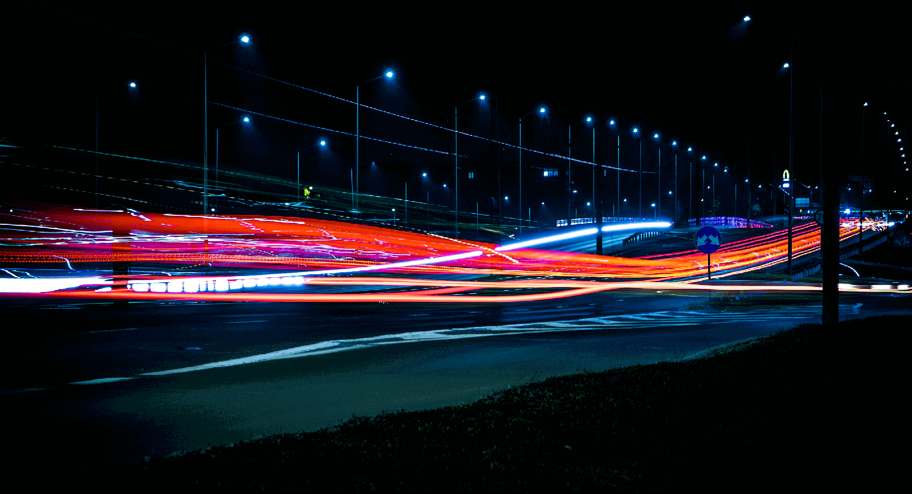
— Profile

Hello!

REY GUILLEN

I’m a Lighting & Compositing Artist, and This is My Story.
I thrive when building and working with passionate teams who fuel my need for creating content which inspire my peers, future artists, and bring hours of joy to players and viewers.

— Experience
Occupy an expert level role creating cinematics and in-game lighting for AAA titles. Architect new tools and workflows for global teams and lead the implementation of software, standards, and quality controls.

Ubisoft, Toronto 2020—Present
- Far Cry 6, Expert Senior Lighting Artist of Cinematics. Light gold-level shots for key cinematics and global marketing materials. Assist Art Director color grading final sequences. Train lighters and manage day-to-day lead responsibilities for cinematics team.

Electronic Arts, Tiburon 2012—2019
- Madden19 - “Longshot 2”, Senior Lighting Artist of Cinematics. Collaborated with Technical Artists to create tools for accelerating workflows. Communicated needs between Concept Artists and Art Director to execute final look. Trained outsourcing located in China to produce emotionally impactful lighting to meet creative standards.
- Battlefield V, Senior Lighting Artist of Cinematics. Worked remotely with the Battlefield team located at DICE Sweden to move projects through the pipeline from concept to delivery of cinematics.
- Madden18 - “Longshot”, Lead Senior Lighting Artist of Cinematics. Architected and implemented a complete workflow in Frostbite which was adopted globally by multiple EA studios due to greatly increased efficiency. Led a studio-wide training initiative for lighting in Frostbite and PBR. Structured methodology to quickly onboard Lighting Artists. Worked with stakeholders across departments to convey lighting team needs and manage project.
- Rory McIlroy PGA Tour, Lead Senior Lighting Artist. Pioneered new lighting techniques for this first sports title to adopt the Frostbite Engine and to implement PBR. Worked closely with the TA to push the game engine to its limits and build a new suite of native tools, such as a PBR color picker. Organized post mortem project to identify weaknesses and bottlenecks to solve for future projects.
- NBA Live 16, Senior Lighting Artist. Troubleshot issues within the NBA Live pipeline and generated suggestions for best practices to increase efficiency in future iterations.
- Tiger Woods PGA Tour 14, Lead Lighting Artist. Worked with the TA to refine workflows. Updated the sky system, lit environments, and tuned skies for improved performance.
- Madden 13, Lighting Artist. Lit environments and tuned skies.
- Tiger Woods PGA Tour 13, Lead Lighting Artist. Employed knowledge from the film industry to introduce new techniques, methodologies, and tools to transition a traditionally manual process to a more organized and automated execution.

Reel FX Creative Studios 2009—2012
- Open Season 3, Lighting and Compositing Artist. Communicated needs of Sony Pictures to team members. Developed methods and tools to help me complete the most shots out of the entire lighting team while maintaining quality and a unified look.
- Judy Moody, Lighting and Compositing Artist/Lead. Guided colleagues to create a high-quality product with a quick turn around for the client while maintaining team morale.
- The Baby Peas, Lighter. Collaborated with creative team for Will.i.am on unreleased short for the Black Eyed Peas/Chatter Super Bowl promotion for SalesForce.
- Ice Age: A Mammoth Christmas, Research and Development. Guided BlueSky, in producing detailed documentation for training artists in the use of Pixar Renderman.
- Looney Tunes, Keyshot Lighting and Compositing Artist. Generated master lighting
and comps for Warner Brothers which were used throughout production as the basis
for same-as shots. Led mentorships through an internship program.

Ignition Entertainment 2009
- Reich, Lighting Supervisor. Led a lighting team on the unreleased console/PC game Reich. Communicated direction and needs of the Art Director and Concept Artists to Lighting and invested departments to establish the look and mood for the Reich universe.

Electronic Arts 2008—2009
- Tiger Woods 2010, Environment Artist. Created new and adjusted existing textures, blend strips, reflection maps, and degradation maps to realize stronger interaction with in-game lighting effects. Additionally baked occlusion and shadow maps, did environment layout, and was tasked with Look Dev for sky domes.

Reel FX Creative Studios 2006—2008
- Open Season 2, Lighting and Compositing Artist. Aided Leads in optimizing workflows
to produce on abbreviated schedules. Trained colleagues on project-specific methods.
- Boz, Lighting and Compositing Artist. Set, character, and prop lighting for series and movie.
- Very First Noel, Lighting Assistant. Corrected technical errors for output from rendering farm. Aided in render layers setup and cleaned up lighting files and Nuke comp files.

— Recognition

Looney Tunes: I Tawt I Taw A Puddy Tat, Academy Award short list 2012

Looney Tunes: I Tawt I Taw A Puddy Tat, Annie Award nominee 2011

Ice Age: A Mammoth Christmas, Annie Award nominee 2011

— Skills
Proficient on Linux, Mac, and Windows with Autodesk Maya, DaVinci Resolve, Adobe Photoshop, Painter, Terragen, Vue, Marmoset, PTGui, Shake, Nuke, Mental Ray, VRay, Pixar Renderman, PBR, HDR, Confluence, Jira, Shotgun, Perforce, Unreal, Frostbite. iPad Pro for color grading.
Working knowledge of stereoscopic production and technical aspects.
Fluent in English and Spanish. Basic proficiency in Japanese.

— Education

Ringling School of Art and Design, Sarasota, FL 2002—2006
- Bachelor of Fine Arts, Major in Computer Animation

